Project Completion Report
MagnoCharge
An Intelligent Auto Disconnect Charger

Submitted by
Dr. Ganta Chamundeswari
Ramachandra College of Engineering
drgantachamu@rcee.ac.in
Date of Submission: 18-09-2025




Contents
Cover Sheet 3
Part A - Summary Report 3
1. Project Objectives 3
2. Deliverables 4
a) Nature of Output: 4
b) Performance specifications: 4
c) Details of engineering designs/ drawings and prototype 4
3. Specific Benefits/Outcome (Please give details) 4
a) Patents filed during the Review Period 4
b) Paper publication/submission in Journal/Symposia/Conferences during the Review Period 4
c) Journal Details with Impact Factors 5
d) Details of the Project Staff working on the project 5
e) Manpower trained (Give details) 5
f) Awareness, training camps, etc. organized 5
g) Summary of significant S&T Achievements 5
h) Project Budget (Final) 5
Part B – Comprehensive Report 6

Cover Sheet
Sr. No. | Name | Details
1 | Project Grant Number | TIH-IoT/2024-11/HRD/CHANAKYA/SL/CFP/155
2 | Project Title | Magno Charge: Intelligent Auto Disconnect Charger.
3 | Principal Investigator (PI)
3.1 | Name | Dr.Ganta Chamundeswari (HOD)
3.2 | Organization | Ramachandra College of Engineering
4 | Co-Principal Investigators (co-PI) :1
4.1 | Name | Y.Nagendra Kumar (Associate Prof.)
4.2 | Organization | Ramachandra College of Engineering
5 | Collaborating Organizations :1
5.1 | Name | Ramachandra College of Engineering
5.2 | Team Members | P. Giridhar, CH.Dileep kumar Reddy, V. Chinni Akash Sri Krishna, K. Vishnu Vardhan Reddy.
5.3 | Activities/Tasks Assigned | Idea and Designing 3D models, App Development, Documentation and Update, Modification.
6 | Date of Project Commencement | 02-December-2024
7 | Approved Date of Project Completion | 01-October -2025
8 | Actual Date of Project Completion

Part A - Summary Report

Project Objectives
Sr. No. | Objective as per the approved Project | Fully Achieved/Partially Achieved (indicate shortfall) | Reason for Partial  Achievement
1 | To design and develop a smart charger system (Magno Charge) that automatically disconnects charging once the battery reaches a predefined threshold. | Fully Achieved | -
2 | To develop an Android mobile application that communicates with the charger for threshold control and monitoring. | Partially Achieved | App prototype developed and background services tested, but advanced analytics and UI insights are pending for the next phase.
3 | To explore intellectual property and research dissemination opportunities. | Fully Achieved | -

Deliverables
Sr. No. | Deliverables as per the approved Project | Fully/Partially/Not Achieved | Reason for Partial/ Non Achievement
1 | Functional prototype of Magno Charge hardware system | Fully Achieved | -
2 | Companion Android app for user control and background automation | Partially Achieved | Core prototype functional; advanced features not implemented yet.
3 | Patent filing and research publication | Fully Achieved | Patent published and paper submitted.

Nature of Output:

Product + Equipment + Software (Android App Prototype)

Product/Equipment: Functional version of Magno Charge hardware (ESP32 based controller + solenoid actuator + magnetic USB cable).

Software/App: Android application for battery threshold monitoring and BLE-based charger control.

Performance specifications:

Process: Automatic detection of charging state and physical disconnection at threshold.

Product: product with ESP32 microcontroller + solenoid actuator + functionally modified USB cable.

Capacity: Supports up to 15W USB-C charging.

Efficiency: >95% charging efficiency maintained; negligible power consumed by microcontroller.

Test Results: Achieved safe cable detachment within 250 ms latency

Details of engineering designs/ drawings and prototype image

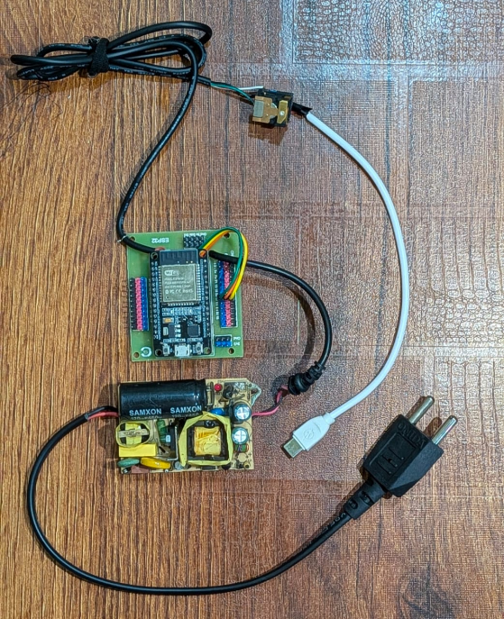
Figure 1: Illustrates the entire prototype image.
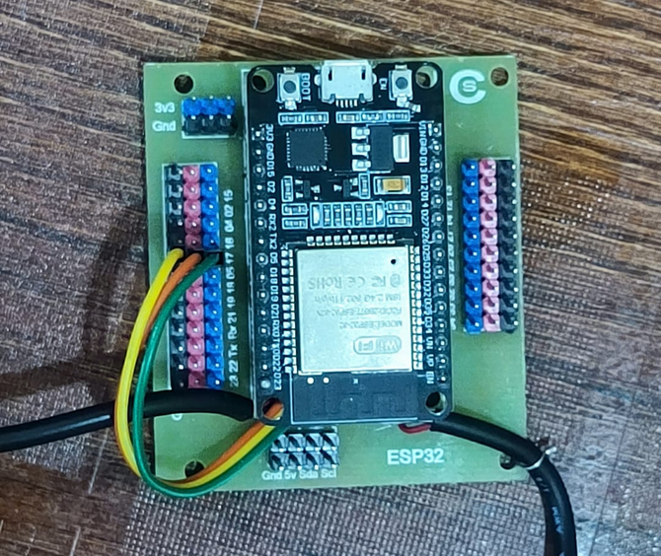
Figure 2: Illustrates the Micro-controller of the system
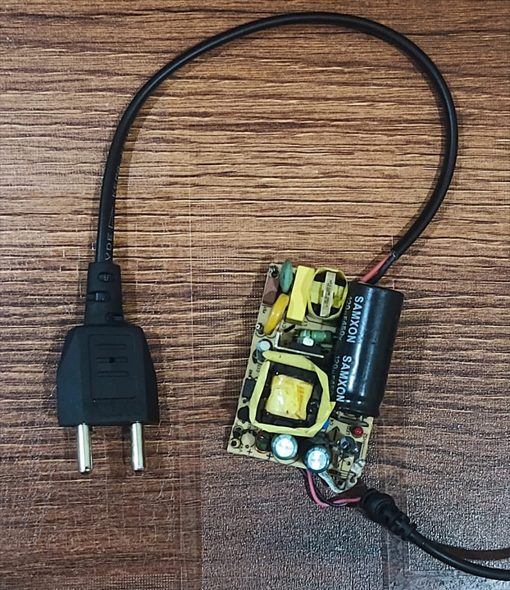
Figure 3: Illustrates the custom adaptor for the system to convert the AC power to DC power.
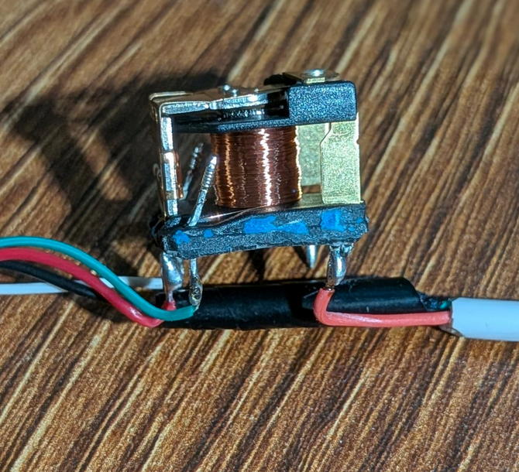
Figure 4: Illustrates the mechanical flap which enables the physical auto disconnection.

Specific Benefits/Outcome (Please give details)

Patents filed during the Review Period
Sr. No | Title | Inventors | Date of Filing
1 | Short-range communication based automatic physical disconnection charger | - Dr. G. Chamundeswari  - P. Giridhar  - CH. Dileep Kumar Reddy  - V. Akash  - K. Vishnu Vardhan Reddy  - Ramachandra College of Engineering | 23/04/2025

Paper publication/submission in Journal/Symposia/Conferences during the Review Period
Title of the paper | Journal/Symposium/Conference | Date of conference | Authors
MagnoCharge An Intelligent Auto Disconnect Charger | 2025 International Conference on signal Processing, Computation, Electronics, Power and Telecommunication | - | 1. Dr. G. Chamundeswari  2. Y. Nagendra  3. P. Giridhar  4. CH. Dileep Kumar Reddy  5. V. Akash  6. K. Vishnu Vardhan Reddy

Journal Details with Impact Factors
Sr. No. | Article Sci Name | Article Sci If | Article Sci Citation | Article Scopus Name | Article Scopus If
1 | NA | NA | NA | NA | NA

Details of the Project Staff working on the project
Sr. No. | Name | Designation | Qualification | Date of joining
1 | Dr. G. Chamundeswari | Principal Investigator | Ph. D | 02-December-2024
2 | Y. Nagendra Kumar | Co-Principal Investigator | M. Tech | 02-December-2024
3 | P. Giridhar | Team Leader | Diploma | 02-December-2024
4 | CH. Dileep Kumar Reddy | Team Member | B. Tech | 02-December-2024
5 | K. Vishnu Vardhan Reddy | Team Member | B. Tech | 02-December-2024
6 | V. Akash | Team Member | B. Tech | 02-December-2024

Manpower trained (Give details)
 | Name | Date of joining
Research Scientists/ Research Associates | Y. Nagendra Kumar (Associate Prof.) | 02-December-2024
No. of Ph.D. (s) produced | Dr. G. Chamundeswari | 02-December-2024
Other Technical Personnel trained | The student members (Team Leader and Team Members) received practical training in embedded systems, PCB design, and prototype testing.  Each team member was trained in handling microcontrollers (Arduino Nano, ESP-32), AC-DC power conversion, and integration of electromagnetic disconnection mechanisms. | 02-December-2024

Awareness, training camps, etc. organized

The project team organized hands-on training sessions for junior engineering students to help them understand the fundamentals of MIT App Inventor, mobile app prototyping, and basics of smart charging technology. This created awareness about sustainable charging practices and inspired them to explore IoT-based projects.

Summary of significant S&T Achievements

Developed two working prototypes of Magno Charge, integrating electromagnet-based auto-disconnection.

Optimized the electromagnet design by reducing flap gaps for stronger and efficient coupling.

Upgraded system to an ESP-32 microcontroller, replacing Arduino Nano for better scalability and Bluetooth integration.

Implemented a custom AC to DC converter, enabling stable charging along with powering the electromagnet.

Designed and tested a functional Android prototype app for threshold monitoring and disconnection signaling.

Successfully validated short-range communication-based disconnection, establishing proof of concept.

Filed a patent, currently published and under examination.

Published a research paper titled “Short-range communication based automatic physical disconnection charger”.

Project Budget (Final)
]
Sr. No. | Budget Head | Funds Sanctioned | Expenditure | % of Total
1 | Manpower | 4,00,000 | 4,00,000 | 83.16%
2 | Consumables | 30,000 | 30,000 | 6.25%
3 | Contingencies | 10,000 | 10,000 | 2%
4 | Travel | 7,500 | 7,500 | 1.5%
5 | Others, if any | 2500 | 2500 | 0.5%
6 | Overhead expenses | 10,000 | 10,000 | 2%
7 | Equipment | 20,000 | 20,000 | 4.16%
 | Total | 4,80,000 | 4,80,000 | 100%

Part B – Comprehensive Report
- Title:

Magno Charge: An Intelligent Auto-Disconnection Charger

- Product/Process as an outcome of the Project, identify Beneficiaries

The outcome of the project is a smart charging adapter system that ensures automatic physical disconnection of the charging cable once a device’s battery reaches a preset threshold. The solution integrates an electromagnet-driven mechanism with an ESP-32 microcontroller and wireless communication for intelligent control.
The primary beneficiaries are:
- Smartphone users who seek extended battery life and safer charging.
- Consumer electronics manufacturers integrating battery-protection technology.
- Sustainable energy advocates aiming to reduce power wastage.
- Researchers and developers exploring advanced power management systems.

- Scientific Description of the Product/Process

Magno Charge consists of a custom-designed electromagnet mechanism, a 15W AC-DC converter, and an ESP-32 microcontroller with built-in Bluetooth for device communication. A modified USB port ensures power transfer while controlling the electromagnet’s activation. Once the preset charge threshold is detected via Bluetooth communication, the system deactivates the electromagnet, triggering the charging tip to detach physically, thereby ensuring complete disconnection.
Specifications/Standards:
- Input: 100–240V AC, 50/60Hz
- Output: 5V/3A (15W) DC
- Microcontroller: ESP-32, dual-core, integrated Bluetooth/Wi-Fi
- Electromagnet: Optimized flap-gap design for efficient coupling
- Communication: Bluetooth Low Energy (BLE) standard
- Connector: USB to Type-C
- Detachment Time: <300 ms latency after threshold is reached

- Methodology adopted for Development of the Product/Process

The methodology adopted for Magno Charge followed a systematic progression that began with problem identification, advanced through iterative prototype development, and culminated in refined system integration. The project was motivated by the limitations of conventional charging systems, particularly the issue of trickle charging in lithium-ion batteries, which leads to accelerated degradation, residual current flow, and user inconvenience. These factors served as the primary drivers for innovation and shaped the design objectives of the system.
The initial prototype served as a proof of concept, employing an Arduino Nano microcontroller, an external Bluetooth module, and a hand-wound electromagnet coil. This version successfully demonstrated the feasibility of using electromagnetic detachment to achieve complete physical disconnection between the charger and the mobile device. However, shortcomings became apparent during testing, including limited magnetic efficiency due to larger air gaps, power delivery constraints from a low-capacity supply, and the complexity of interfacing multiple discrete modules.
In response, the second prototype was developed with significant refinements to address these limitations. The electromagnet design was optimized by reducing the gap between the flaps, which strengthened magnetic coupling and improved efficiency. The power system was upgraded to a 15W AC–DC converter, capable of providing stable current simultaneously for device charging and electromagnet operation without fluctuations. The most notable advancement was the adoption of the ESP-32 microcontroller, which integrated Bluetooth functionality into the control logic, eliminating the reliance on external modules. This not only reduced hardware complexity but also enhanced scalability and energy efficiency.
Parallel to hardware development, a custom PCB was designed to achieve compactness and organized integration of all components, thereby minimizing energy losses and improving system stability. The software component was prototyped using MIT App Inventor, leveraging Itoo for background service execution and the Bluetooth Client for BLE to establish reliable communication between the mobile device and the charger. The application was tested to monitor battery thresholds and transmit disconnection commands automatically, validating the seamless coordination between software and hardware elements.
Testing confirmed that the system could reliably disconnect charging at the predefined threshold with negligible delay, while maintaining compatibility across multiple smartphone models. This iterative cycle of design, evaluation, and refinement transformed Magno Charge from a conceptual solution into a functional prototype capable of meeting its original objectives: enhancing battery longevity, improving safety, increasing energy efficiency, and offering user-friendly automation.

- Scientific /Technological Formulation giving underlying Basis

The underlying scientific formulation of Magno Charge rests on three principles:
- Electromagnetic Actuation: A miniature electromagnet generates a magnetic field to hold a detachable charging tip in place. When deactivated, the tip automatically detaches, ensuring complete physical disconnection.
- Wireless Communication: Bluetooth Low Energy communication between the ESP-32 microcontroller and the smartphone provides real-time battery monitoring and threshold-based disconnection without additional hardware modification on the phone.
- Optimized Power Management: A high-efficiency 15W AC-DC converter ensures simultaneous powering of both the charging process and the electromagnet with minimal losses, while the ESP-32 enables low-power control operations.
This synergy of electromagnetism, wireless protocols, and microcontroller intelligence creates a system that eliminates trickle charging entirely, thereby enhancing safety, energy conservation, and device longevity.

- Further Work required, if any, to get full Benefits or enhance Utilization.

Although the prototype demonstrates core functionality, several areas require further development to maximize benefits:
- Completion of the Android/iOS application with advanced analytics, threshold customization, and user interface improvements.
- Miniaturization of the electromagnet and PCB for commercial-grade compactness.
- Expansion of fast-charging compatibility standards (e.g., Quick Charge).
- Long-term durability and stress testing across varied environmental conditions.
- Continuous stability for yearly Android releases.

- Recommendations for Utilization of the Product/Process.
For practical deployment, the following steps are recommended:
- Conduct large-scale pilot testing with different smartphone models and charging scenarios.
- Collaborate with charger and accessory manufacturers to integrate Magno Charge technology into mainstream adapters.
- File for international patents to secure intellectual property rights beyond the published one.
- Partner with sustainability-focused organizations to highlight the environmental benefits of reduced energy waste.
- Gradually expand the solution to laptops, IoT devices, and wearables, thereby scaling market reach.

Signature of PI

Name of PI

Signature of Co-PI

Name of Co-PI

